**Lab 1: Basic HTML**

**1.1 HTML Elements**

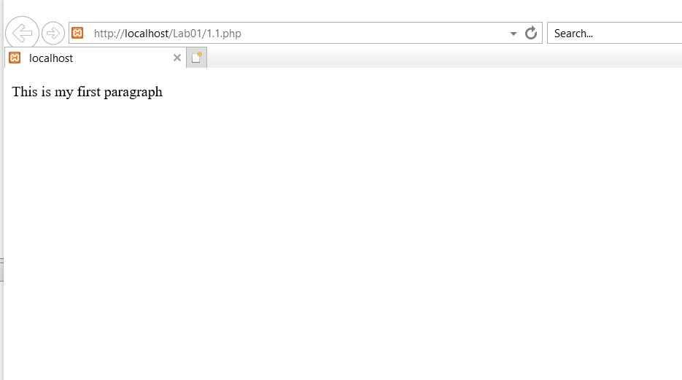

**1.2 HTML Basic**

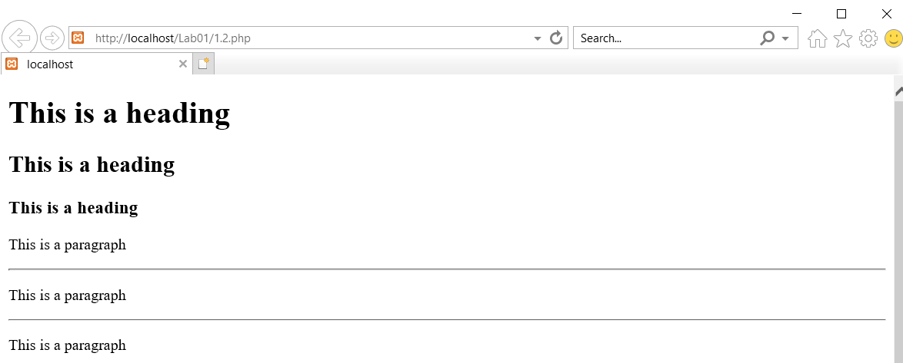

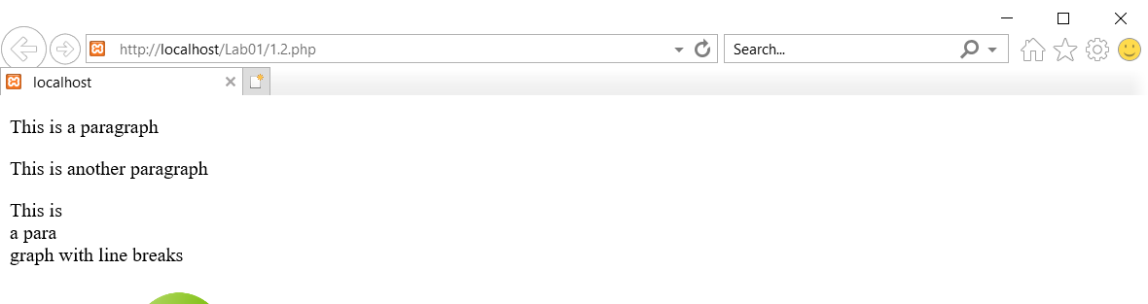

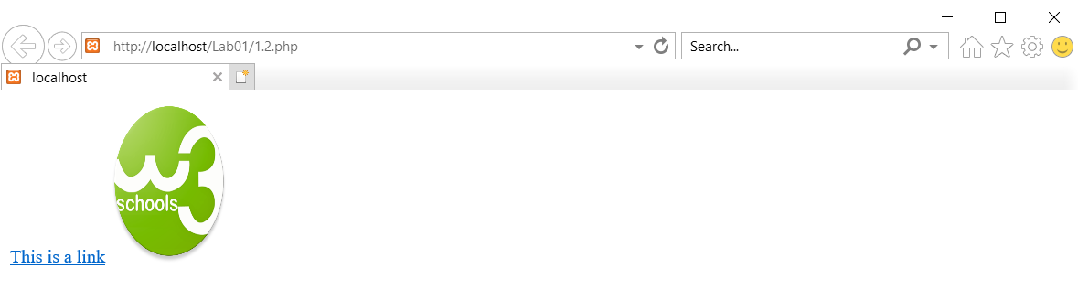

**1.3 HTML Attributes**

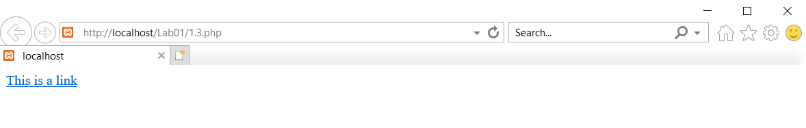

**1.4 HTML Links**

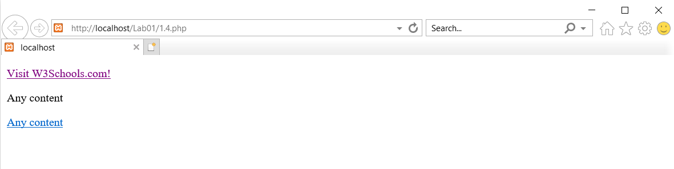**1.5. HTML Tables**

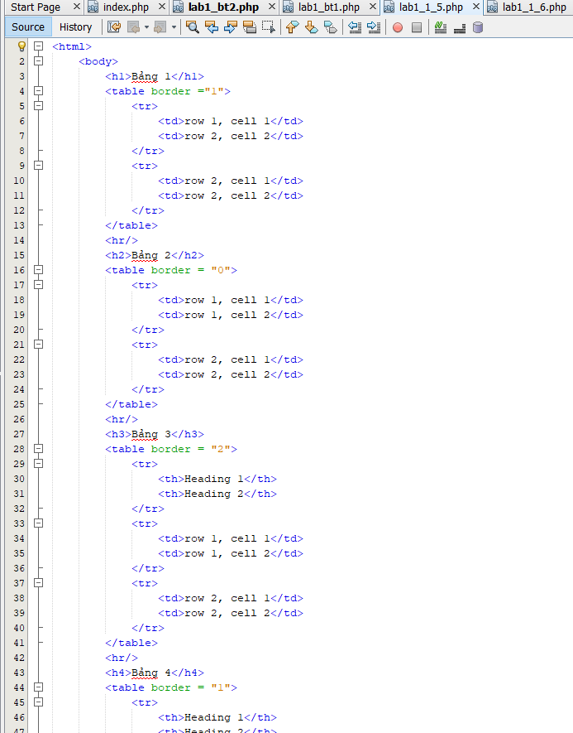

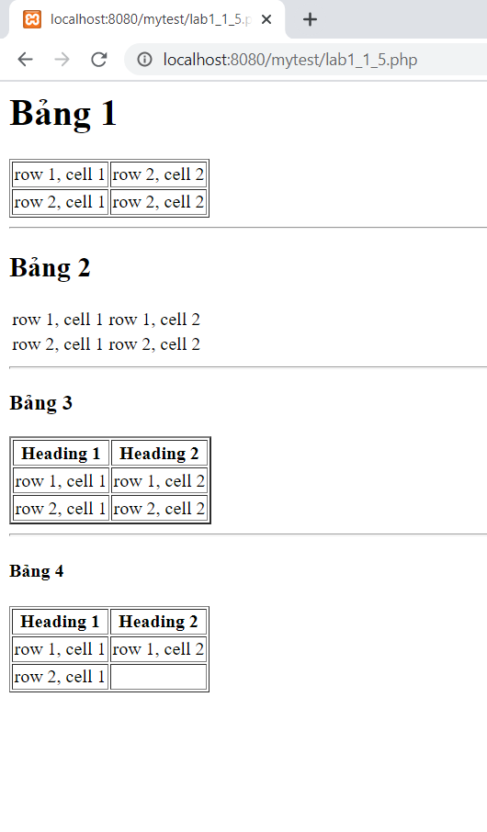

**1.6 HTML Styles**

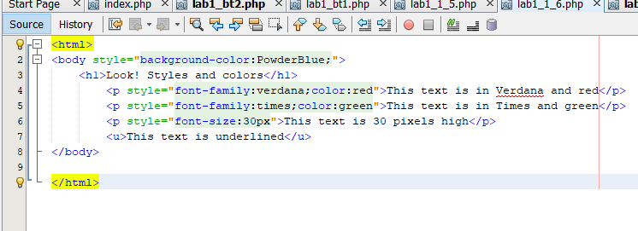

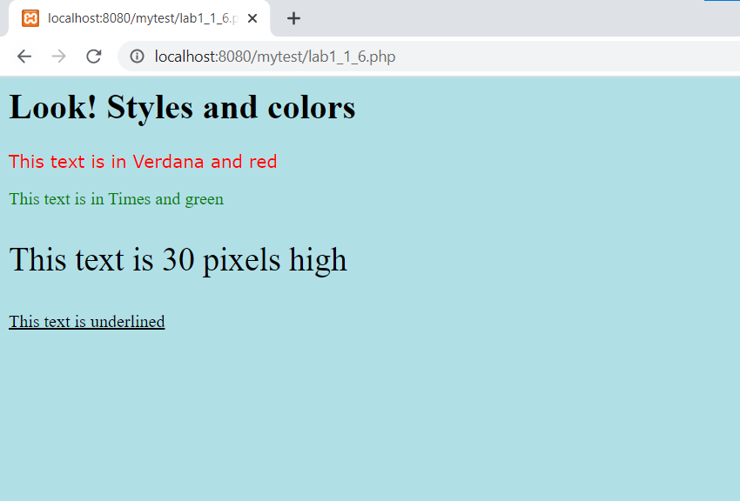

**1.7 HTML Lists**

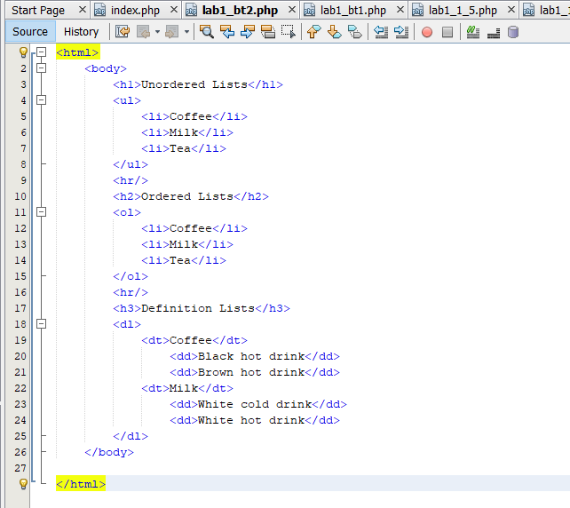

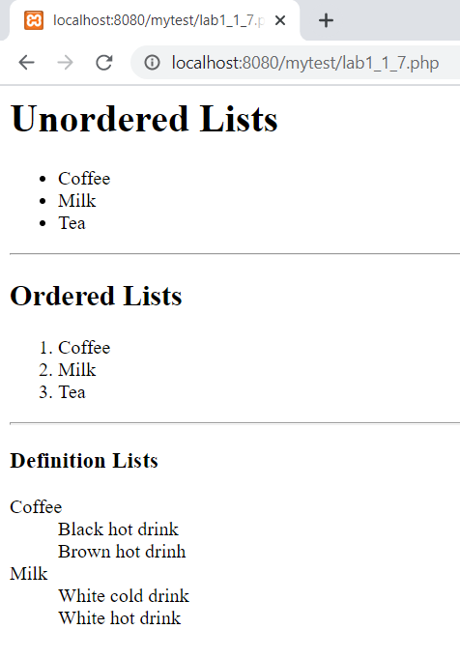

**1.8 HTML Text formating**

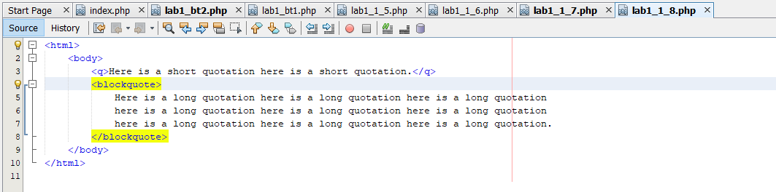

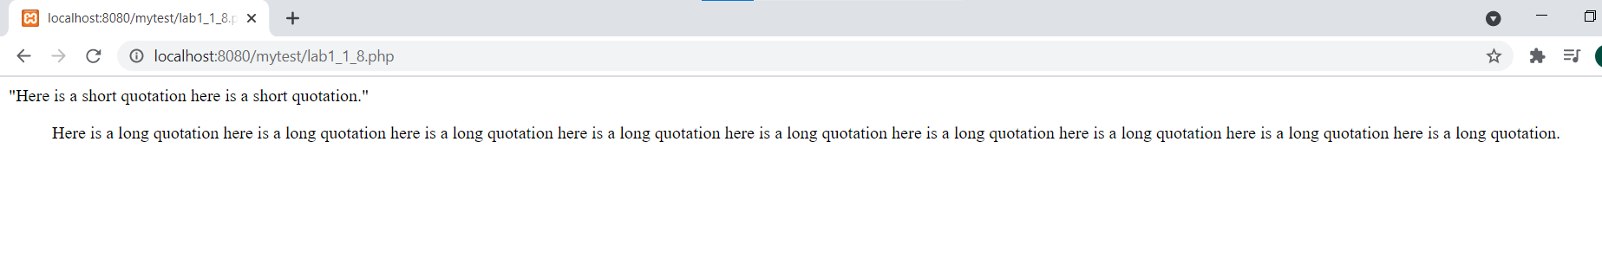

**1.9 Exercise**

**1.9.1 Exercise 1**

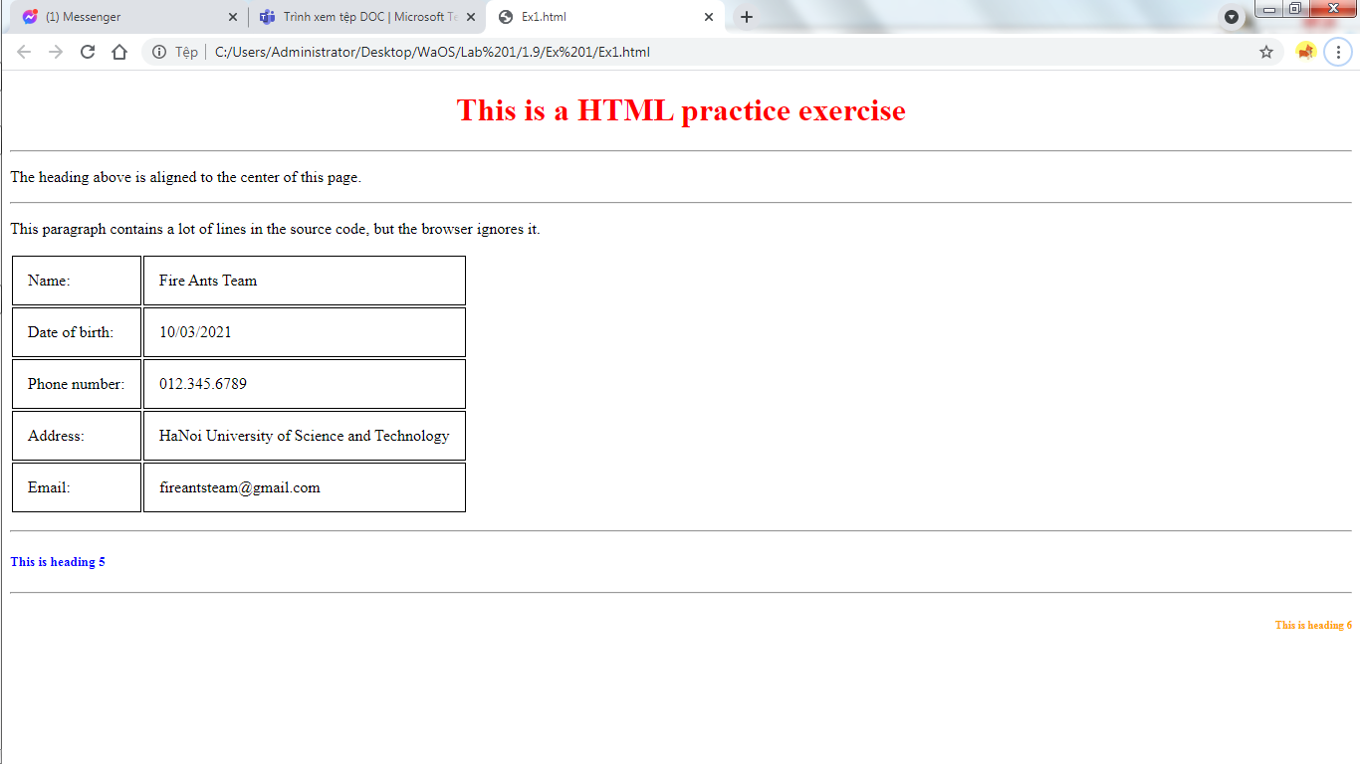

**1.9.2 Exercise 2**

